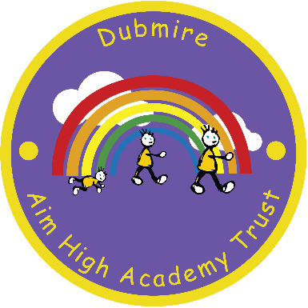

Dubmire Aim High Academy

Britannia Terrace

Fence Houses

Houghton le Spring  
Tyne & Wear DH4 6HL

[Tel: 0191](Tel:0191) 5005958

Head teacher – Miss E Jarvis

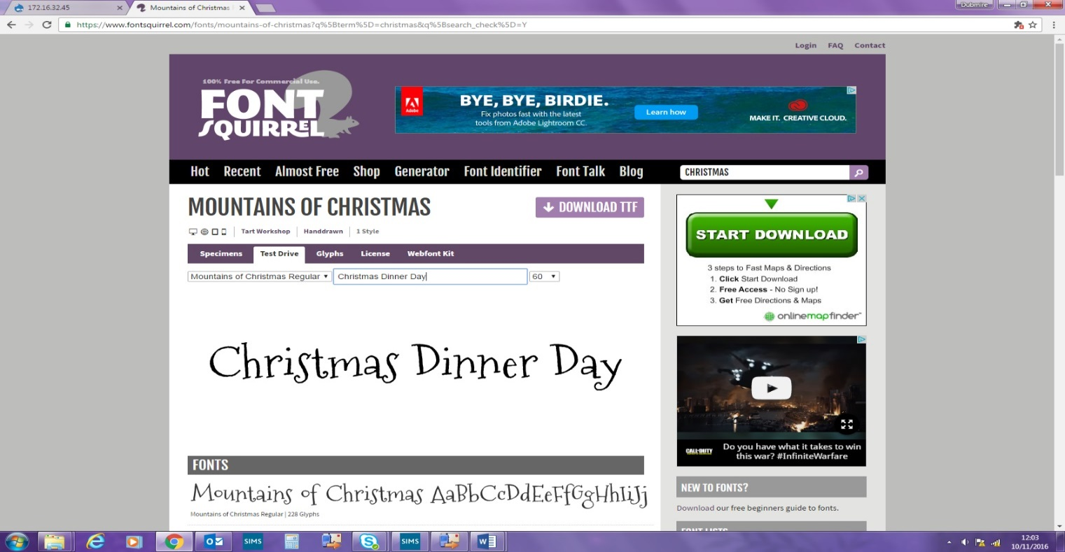

5th November 2019

Dear Parent/Carer,

We would like to give all children who do not usually stay for school meals, the opportunity to join us on Tuesday 10th December for a Christmas Dinner. The cost is £2.20 and if your child would like to stay for dinner on this day please complete and return the slip below **no later than Monday 25th November 2019!**

If you qualify for free school meals (including children in KS1) no payment is required however, you must still return the slip below to school.

Yours faithfully,

E Jarvis

Headteacher

**_____________________________________________________________________**

**Christmas Dinner Day Tuesday 10th December 2019**

Name………………………………………………………………………….…. Class…….…………

**(please tick one of the following)**

My child would like to stay for Christmas Dinner on Tues 10th Dec and I enclose £2.20

My child would like to stay for Christmas Dinner on Tues 10th Dec and I qualify for free school meals

Signed ……………………………………………………………………….………...Date………………………….…